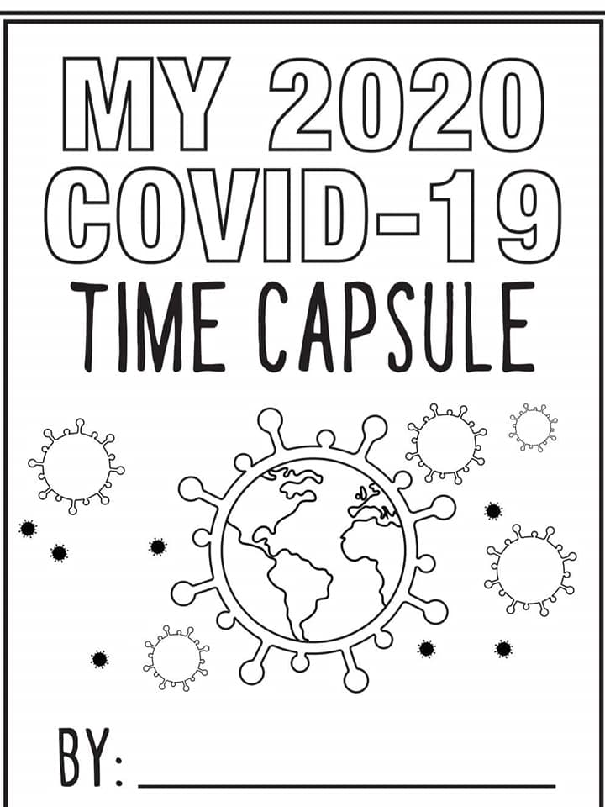

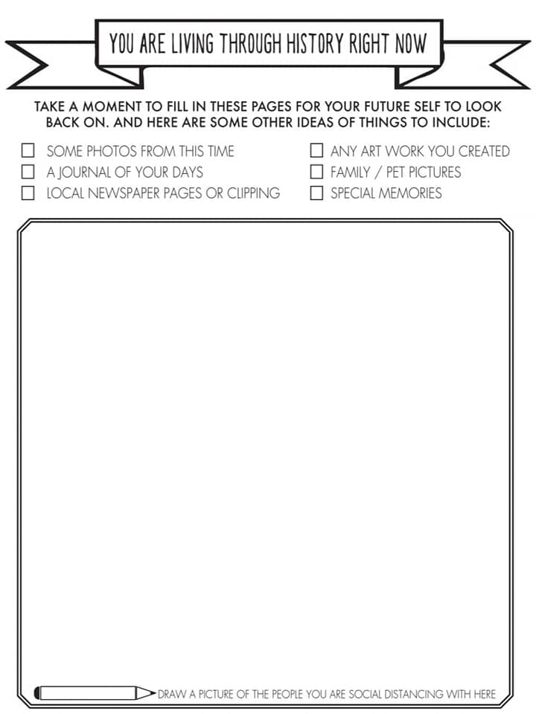

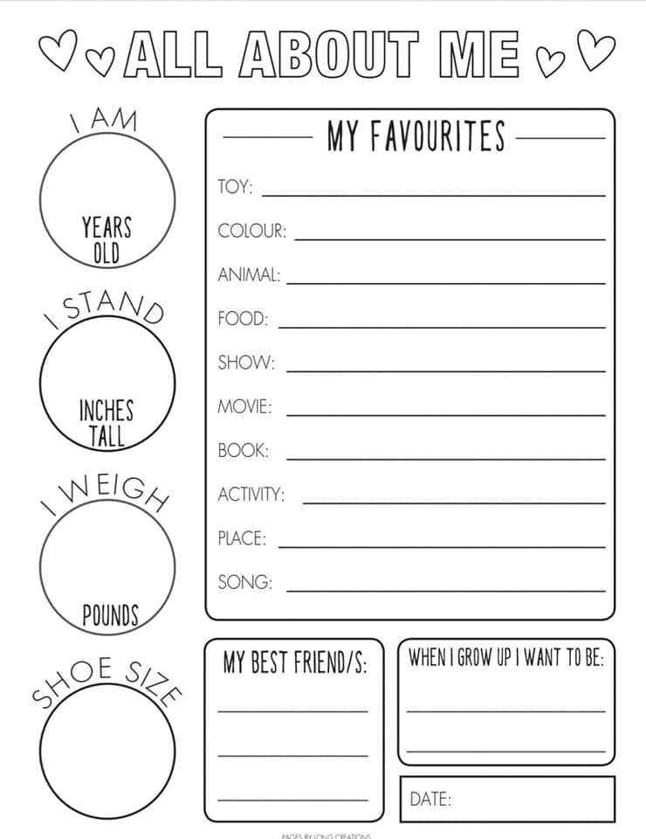

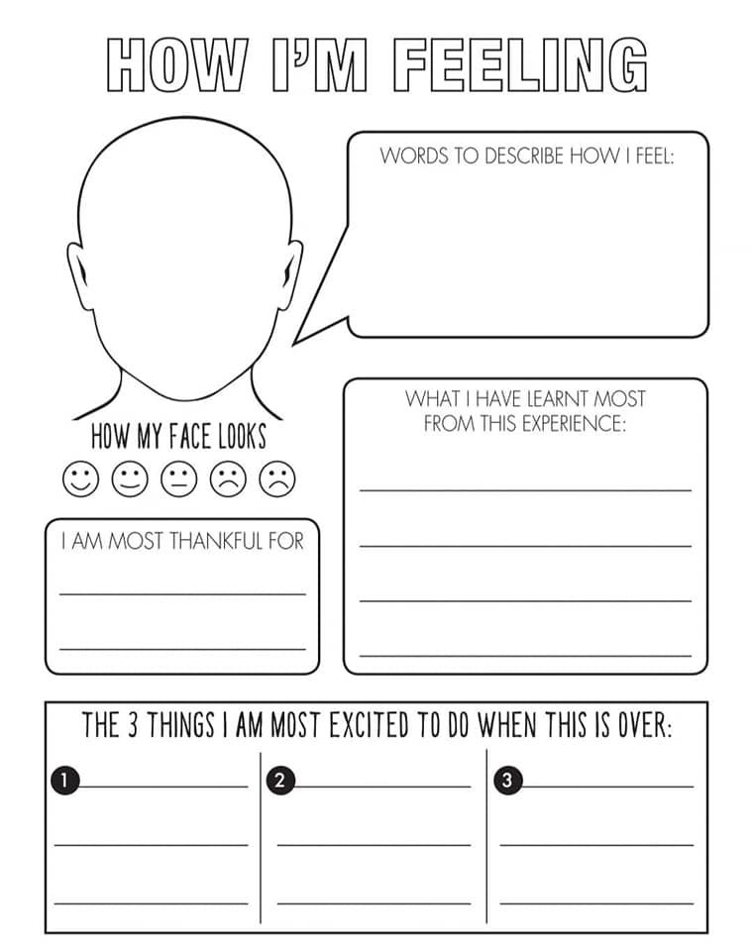

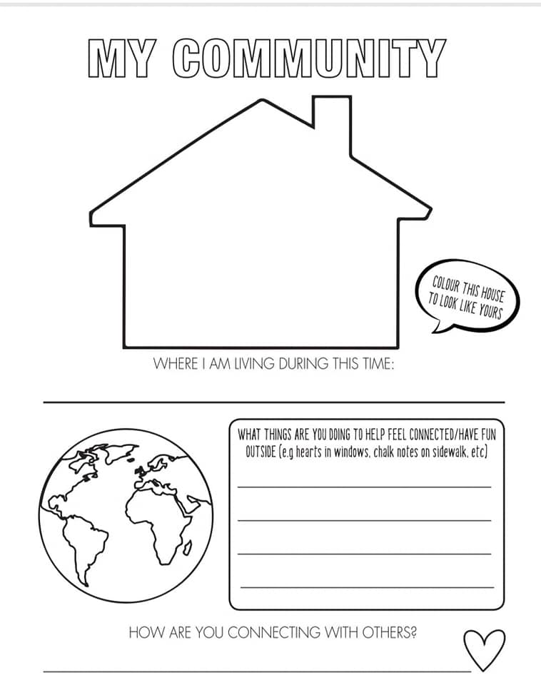

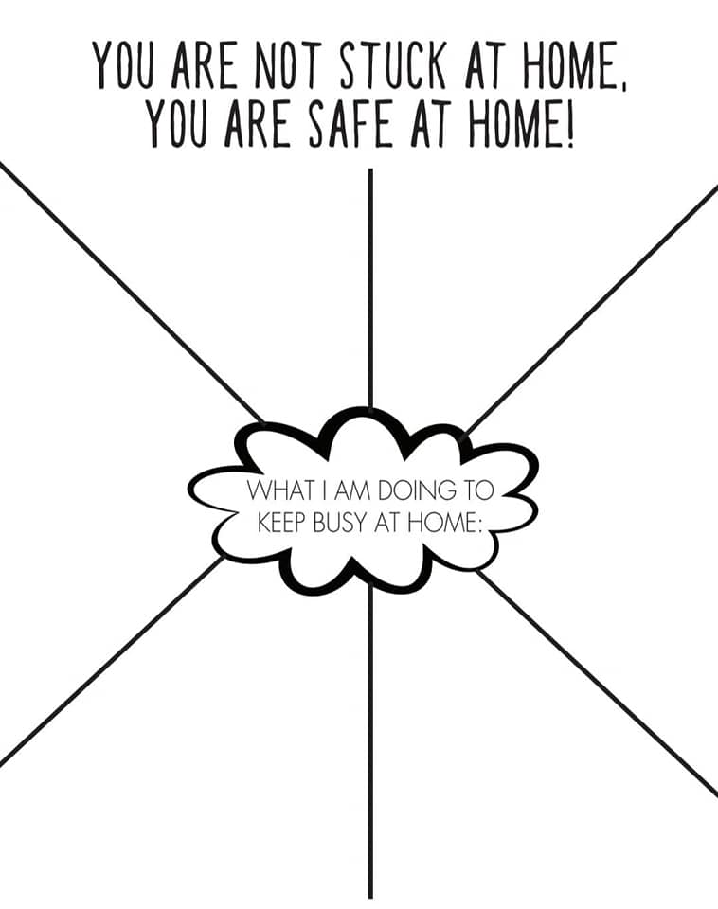



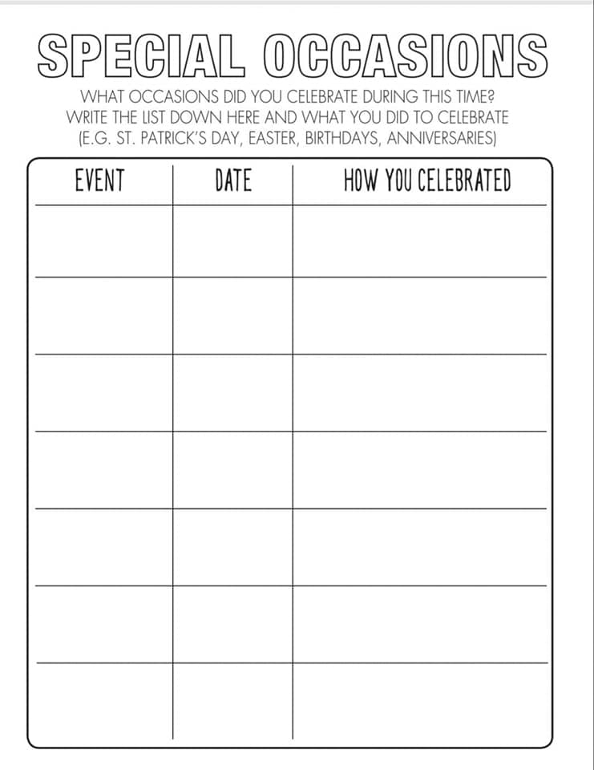

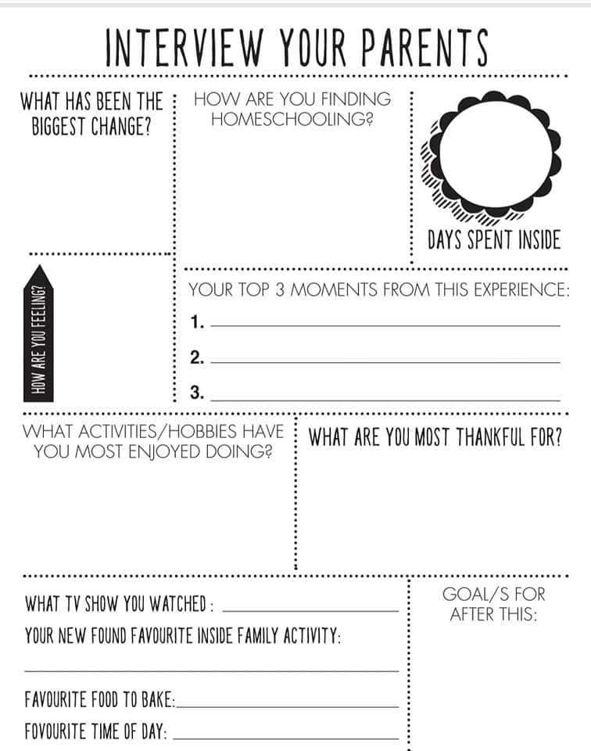

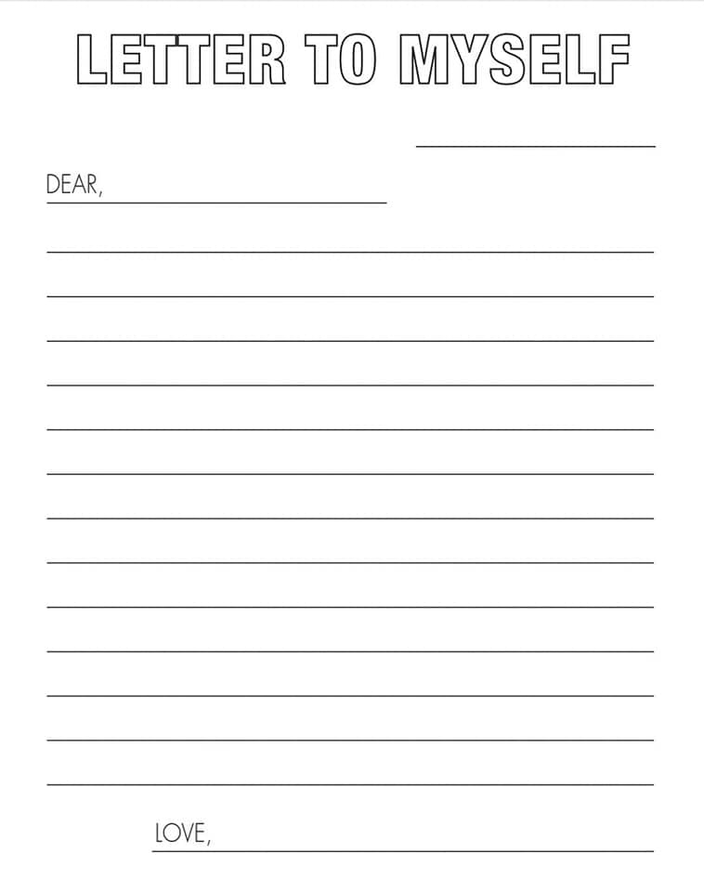

Letter from my parents:

Dear ________________________________________________________________________________________________________________________________________________________________________________________________________________________________________________________________________________________________________________________________________________________________________________________________________________________________________________________________________________________________________________________________

LOVE__________________________